Task 7.2c

Task 1 Inspecting the Environment

What I did:  
I explored the existing AWS setup to understand the starting architecture of the café’s web application.

How I did it:  
I used the Amazon VPC Console to inspect the virtual private cloud, including the public and private subnets, route tables, NAT gateways, internet gateway, and security groups. I also reviewed the existing CafeWebAppServer instance and security group CafeSG to check which ports were open (port 80 for HTTP, port 22 for SSH). This helped me answer the multiple-choice setup questions and understand the current infrastructure layout.

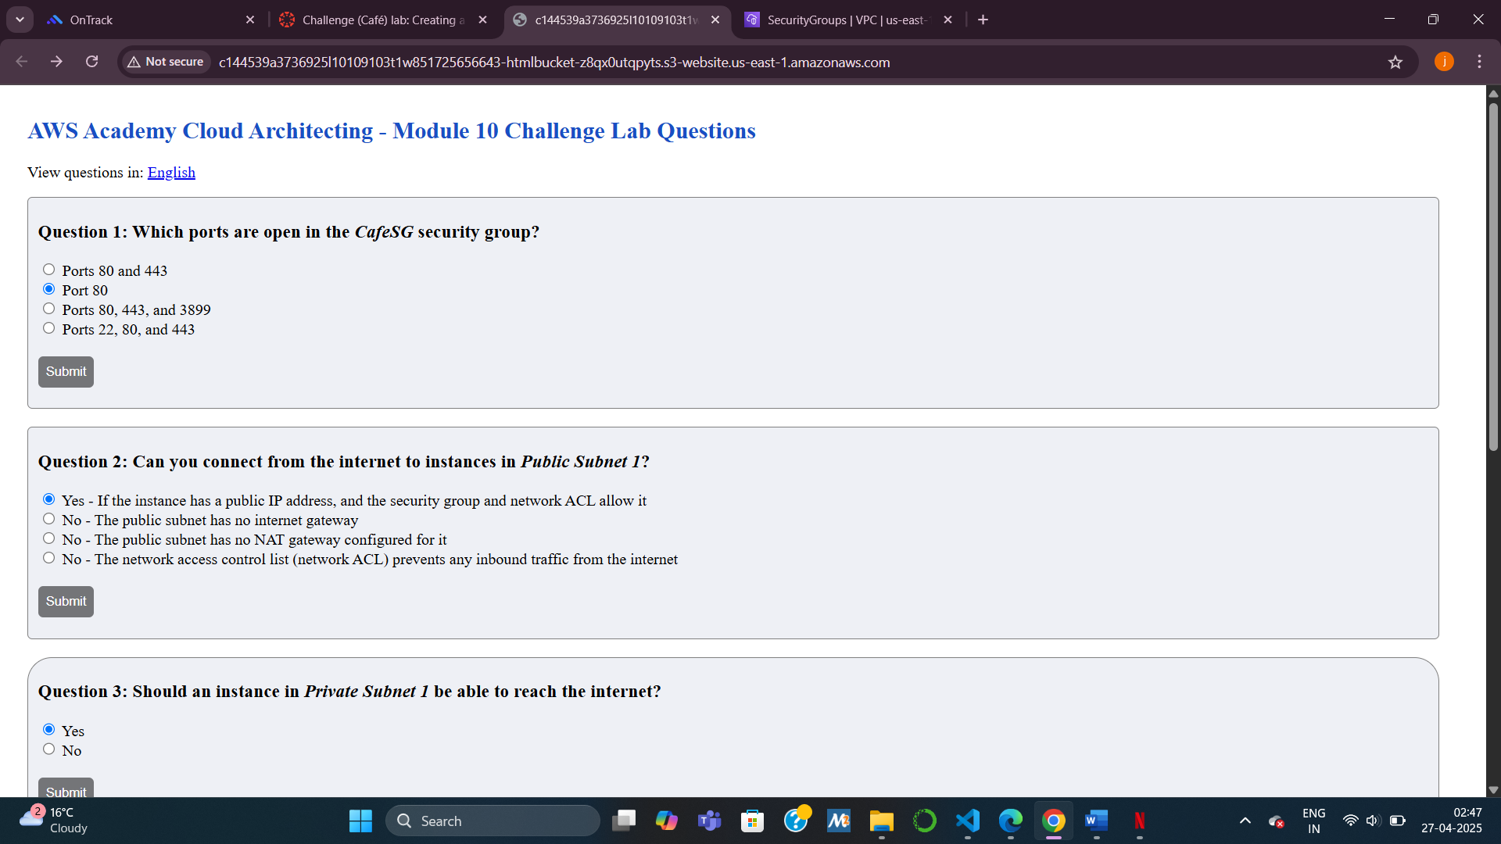

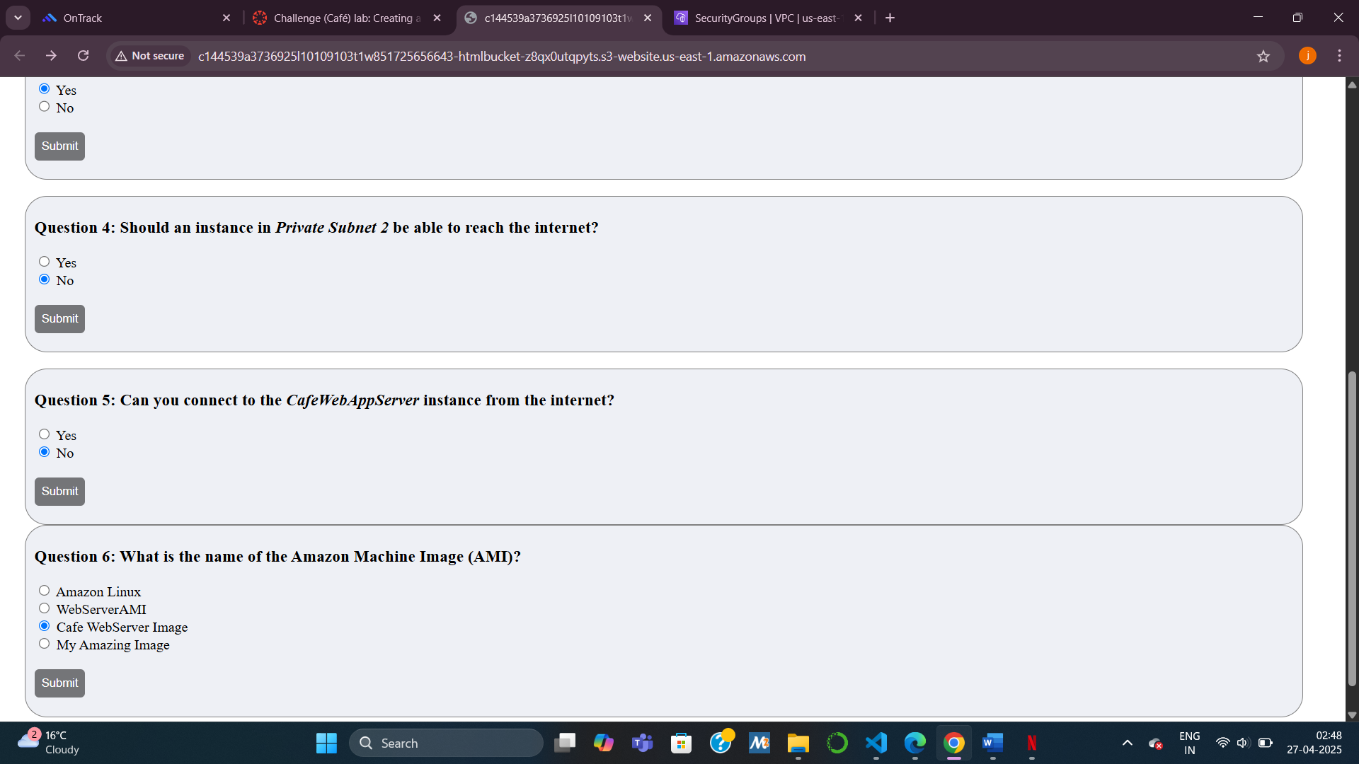

Task 2 Updating a network to work across multiple Availability Zones

What I did:  
I enabled the network to work across multiple Availability Zones to ensure high availability.

How I did it:  
I created a NAT Gateway in Public Subnet 2 to allow internet access for instances in Private Subnet 2. Then I updated the route table for Private Subnet 2 to direct internet-bound traffic through this new NAT Gateway. This mirrored the setup already in place for Private Subnet 1, ensuring both zones were ready for Auto Scaling.

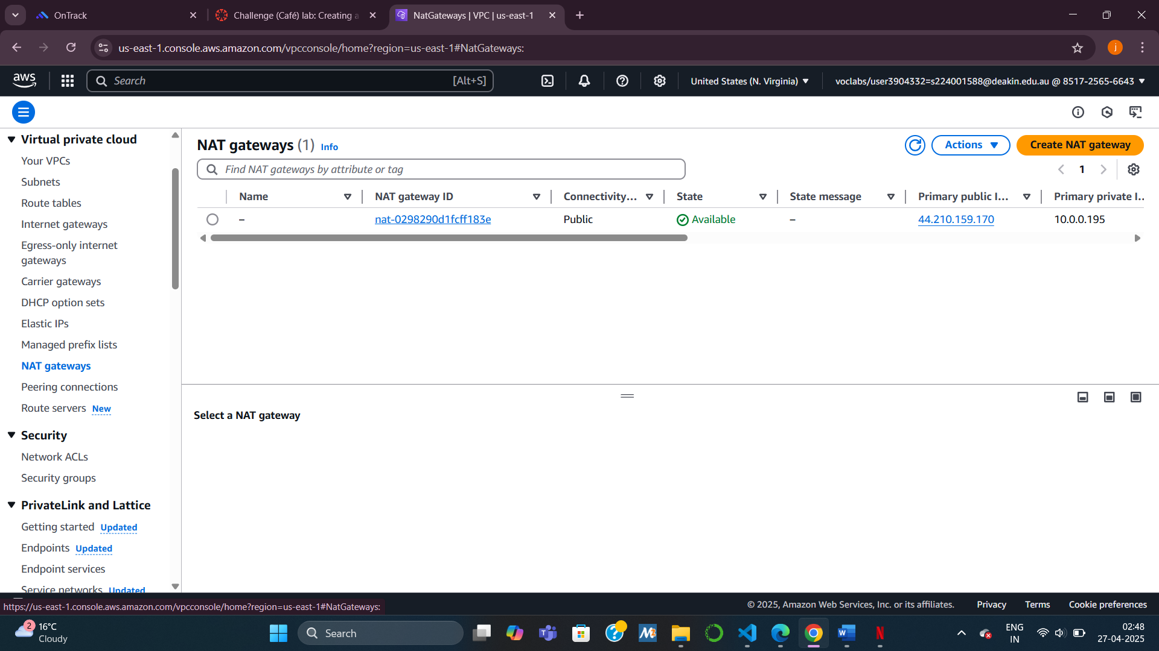

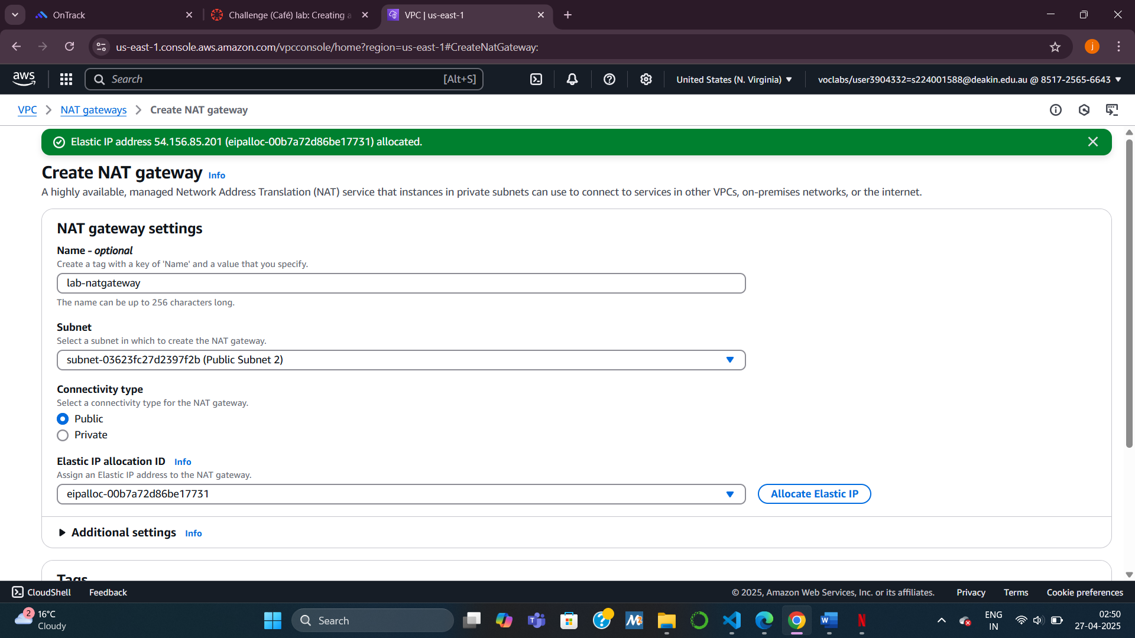

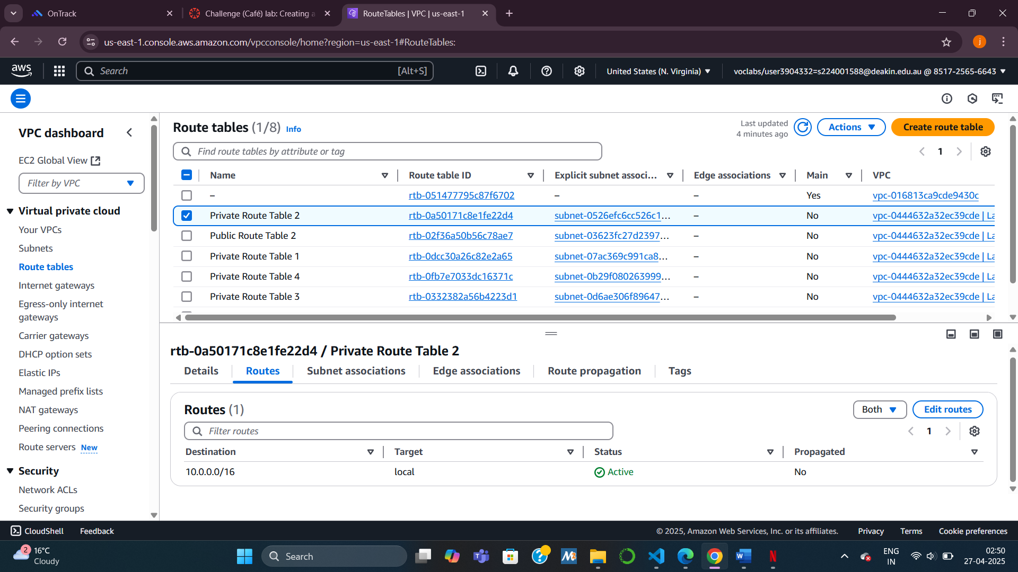

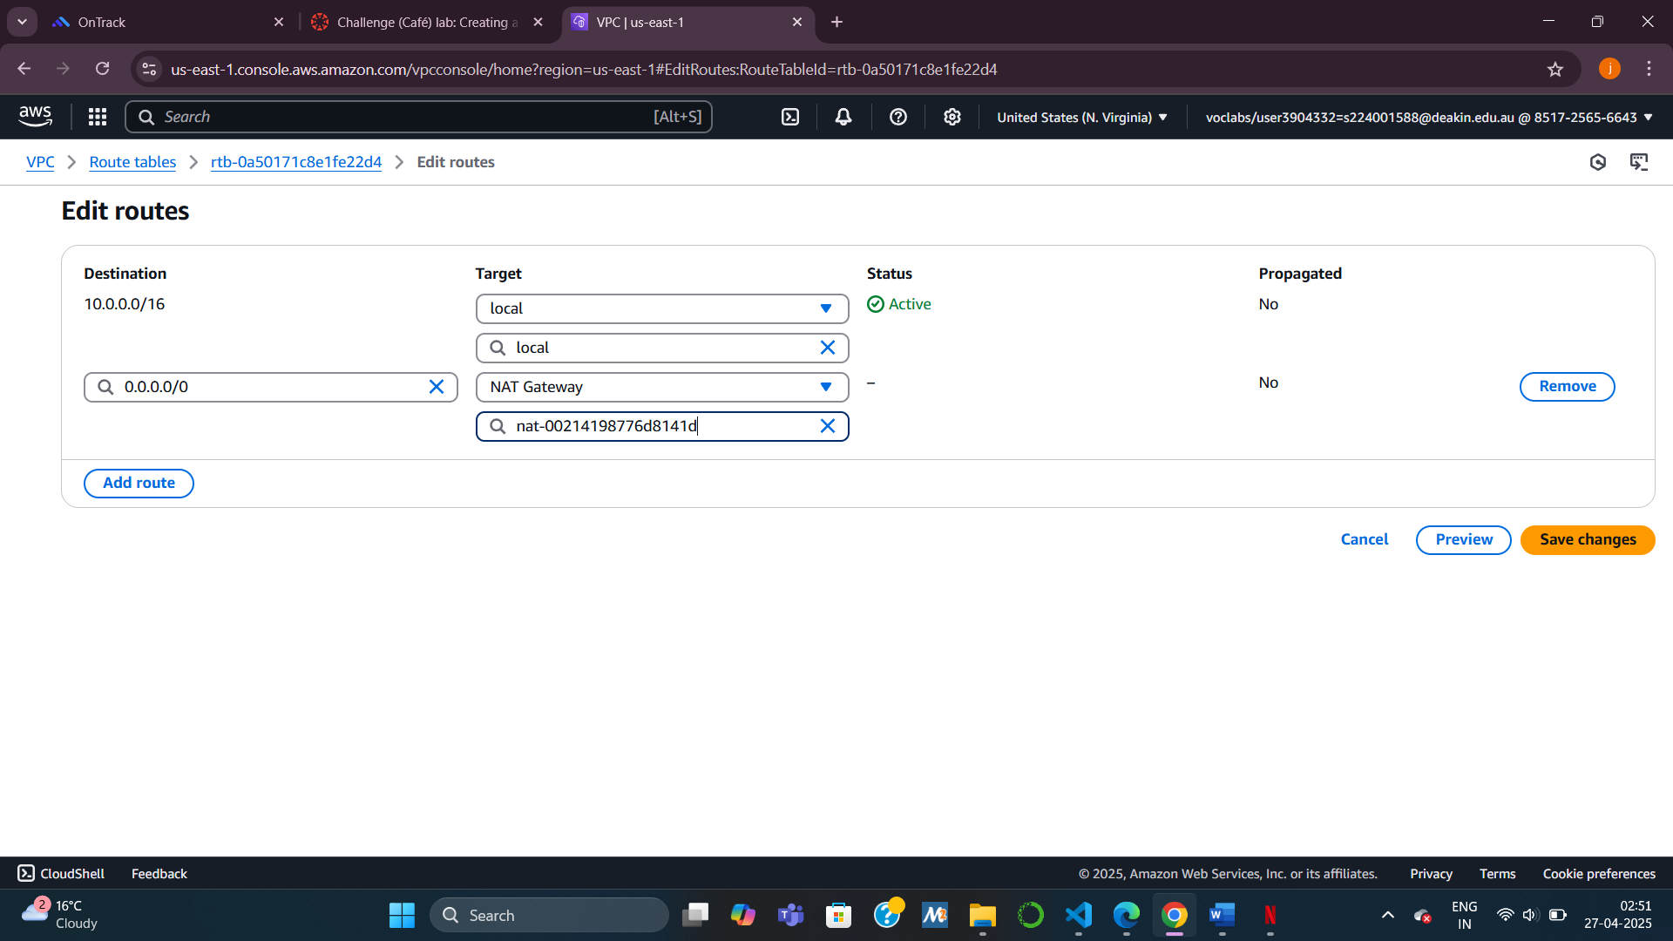

Task 3: Creating a Launch Template

What I did:  
I created a launch template that would be used by the Auto Scaling group to spin up new EC2 instances.

How I did it:  
I selected the Cafe WebServer Image AMI under “My AMIs” and chose the t2.micro instance type. I created and downloaded a new key pair for access. I also attached the CafeSG security group and assigned the CafeRole IAM role. Lastly, I added a tag with the key Name and value webserver to label my instances.

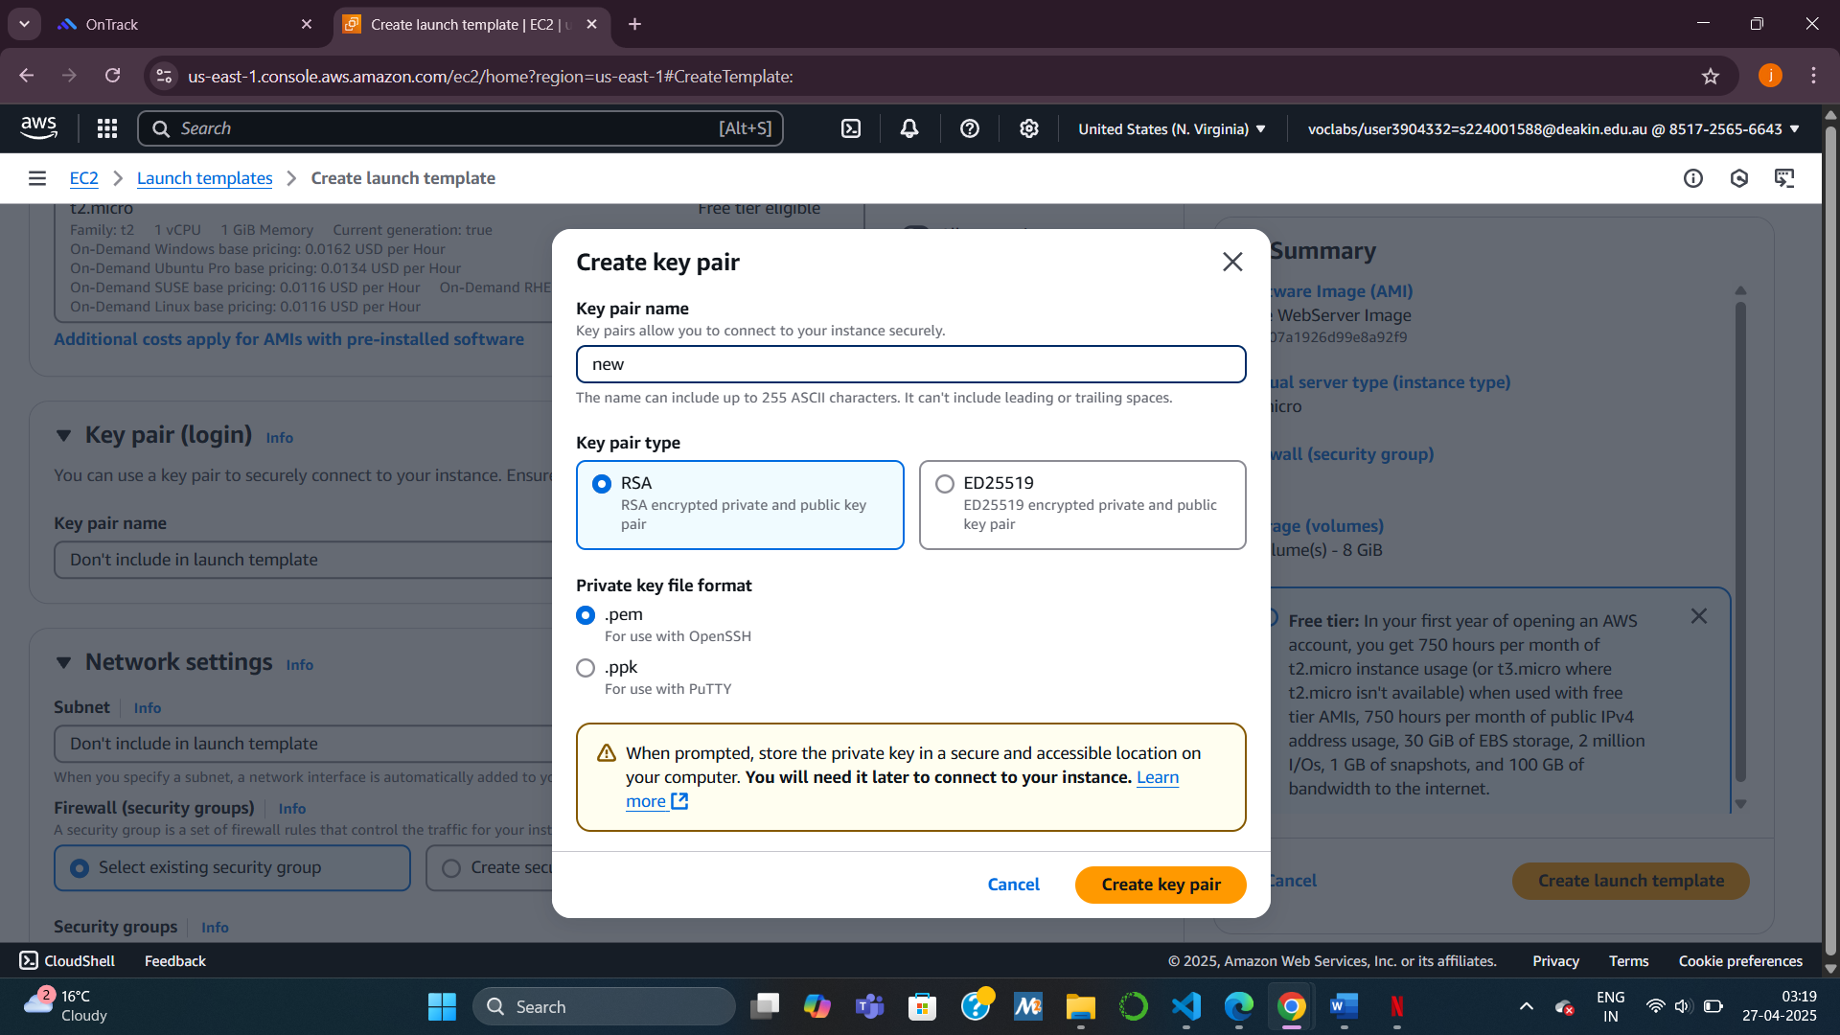

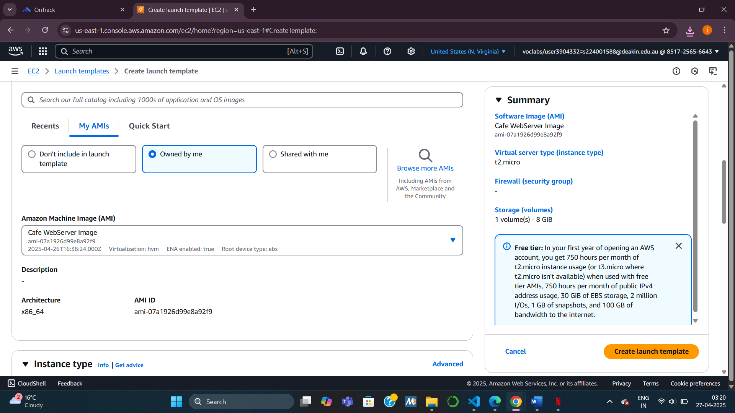

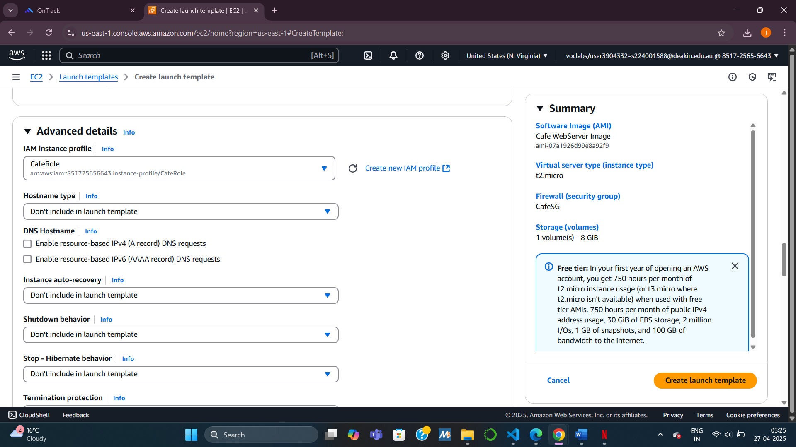

Task4 Creating an Auto Scaling Group

What I did:  
I created an Auto Scaling group to automatically launch new instances based on CPU usage.

How I did it:  
Using the launch template I had created, I set up an Auto Scaling group with:

* Desired capacity: 2
* Minimum: 2
* Maximum: 6  
  I selected both Private Subnet 1 and 2 to ensure high availability. Then, I set a target tracking policy with a CPU threshold of 25% and a warmup period of 60 seconds to trigger scaling events.

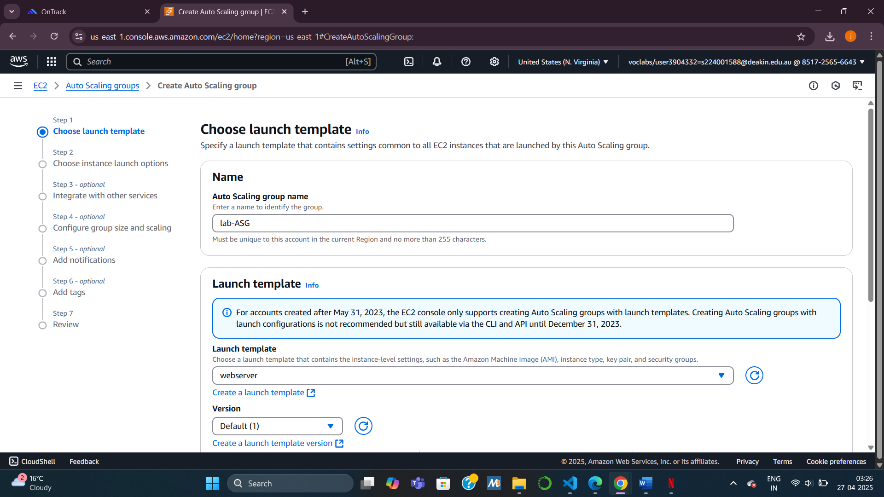

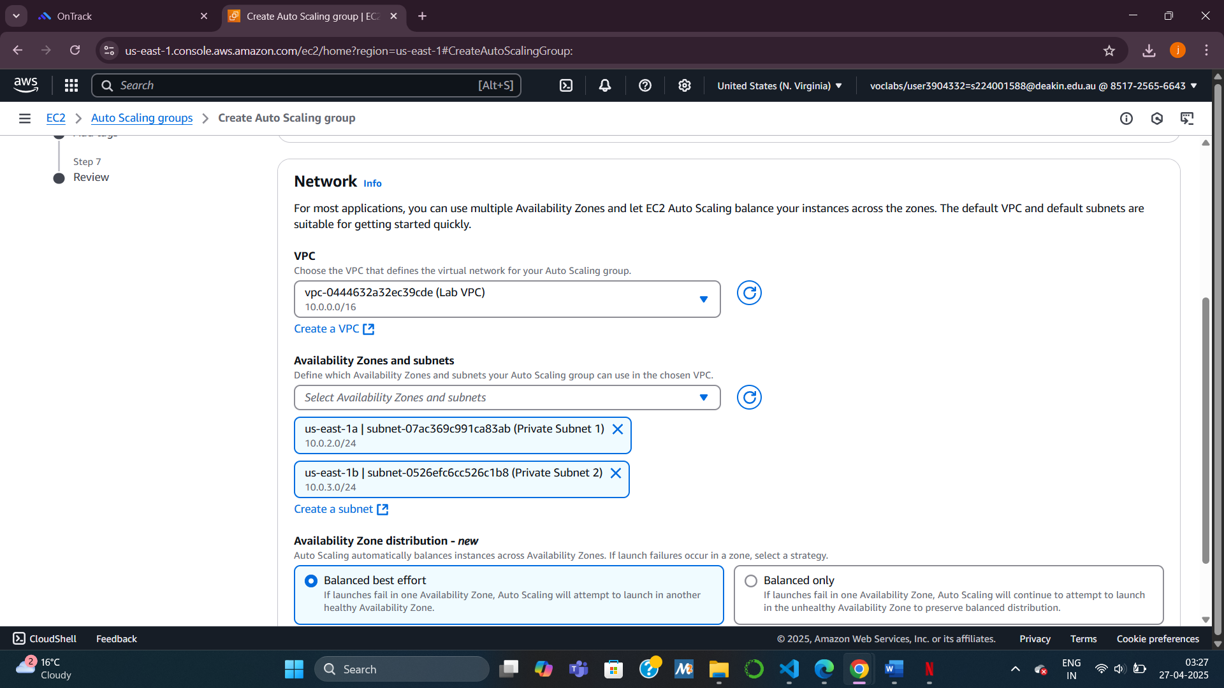

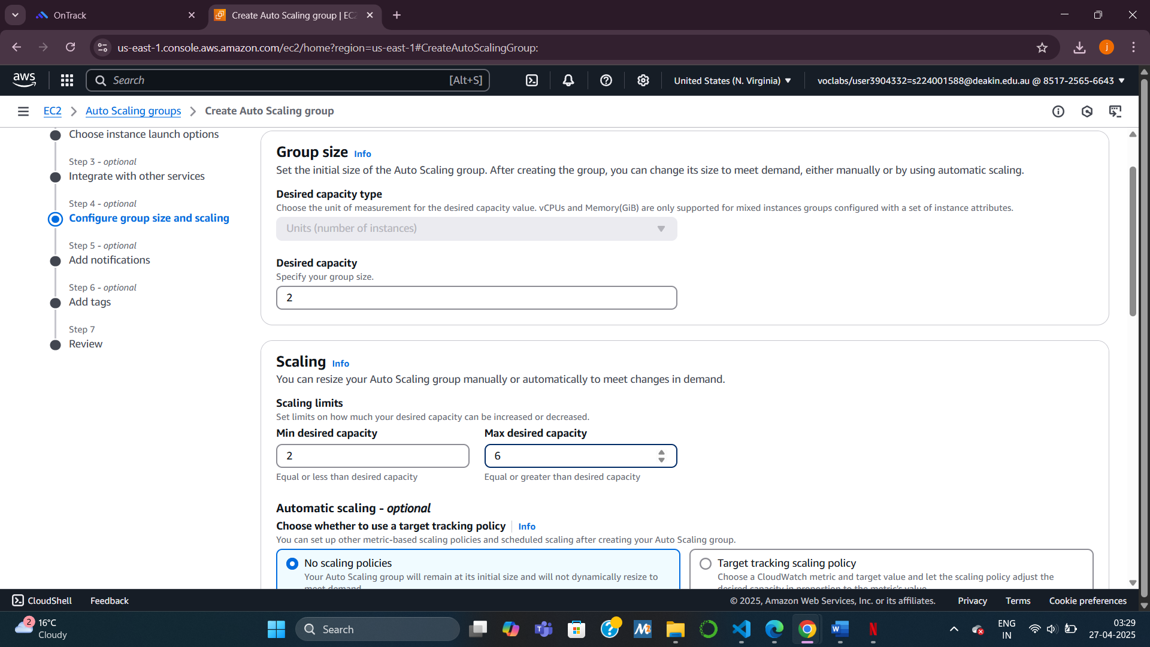

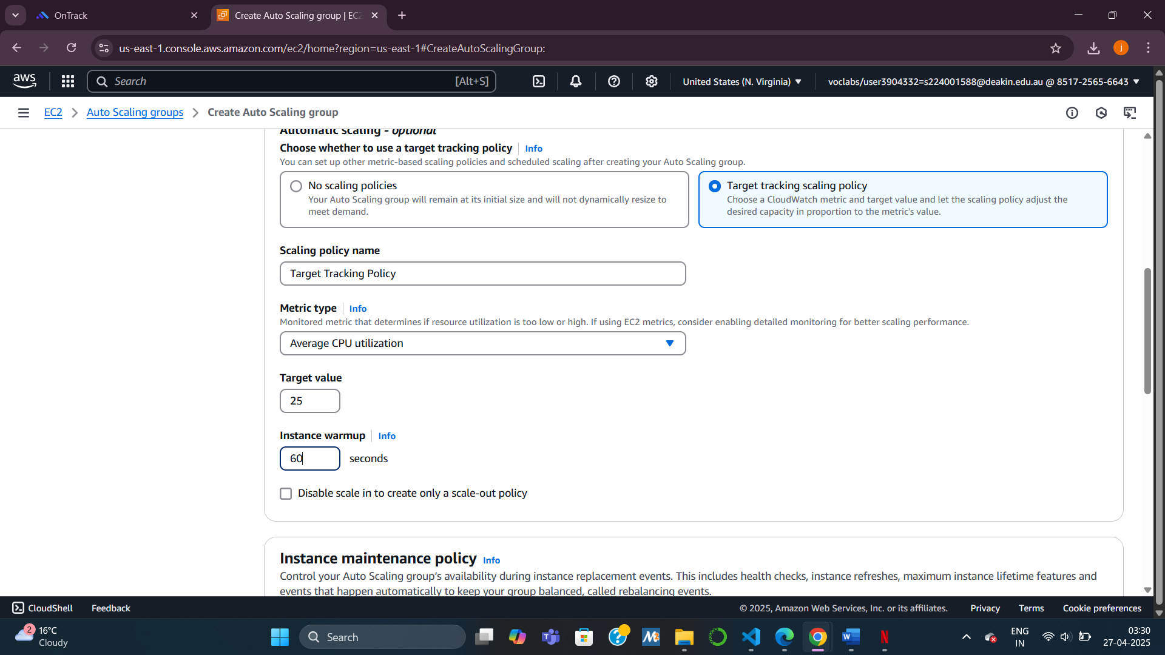

Task5 Creating an Application Load Balancer

What I did:  
I made the web application accessible to the internet by creating an Application Load Balancer (ALB).

How I did it:  
I created an HTTP ALB, attached it to both Public Subnet 1 and 2, and created a new security group that allowed HTTP (port 80) traffic from anywhere. Then I set up a target group and linked it to my ALB. Finally, I modified the Auto Scaling group to register instances to the target group automatically so the load balancer could distribute traffic evenly.

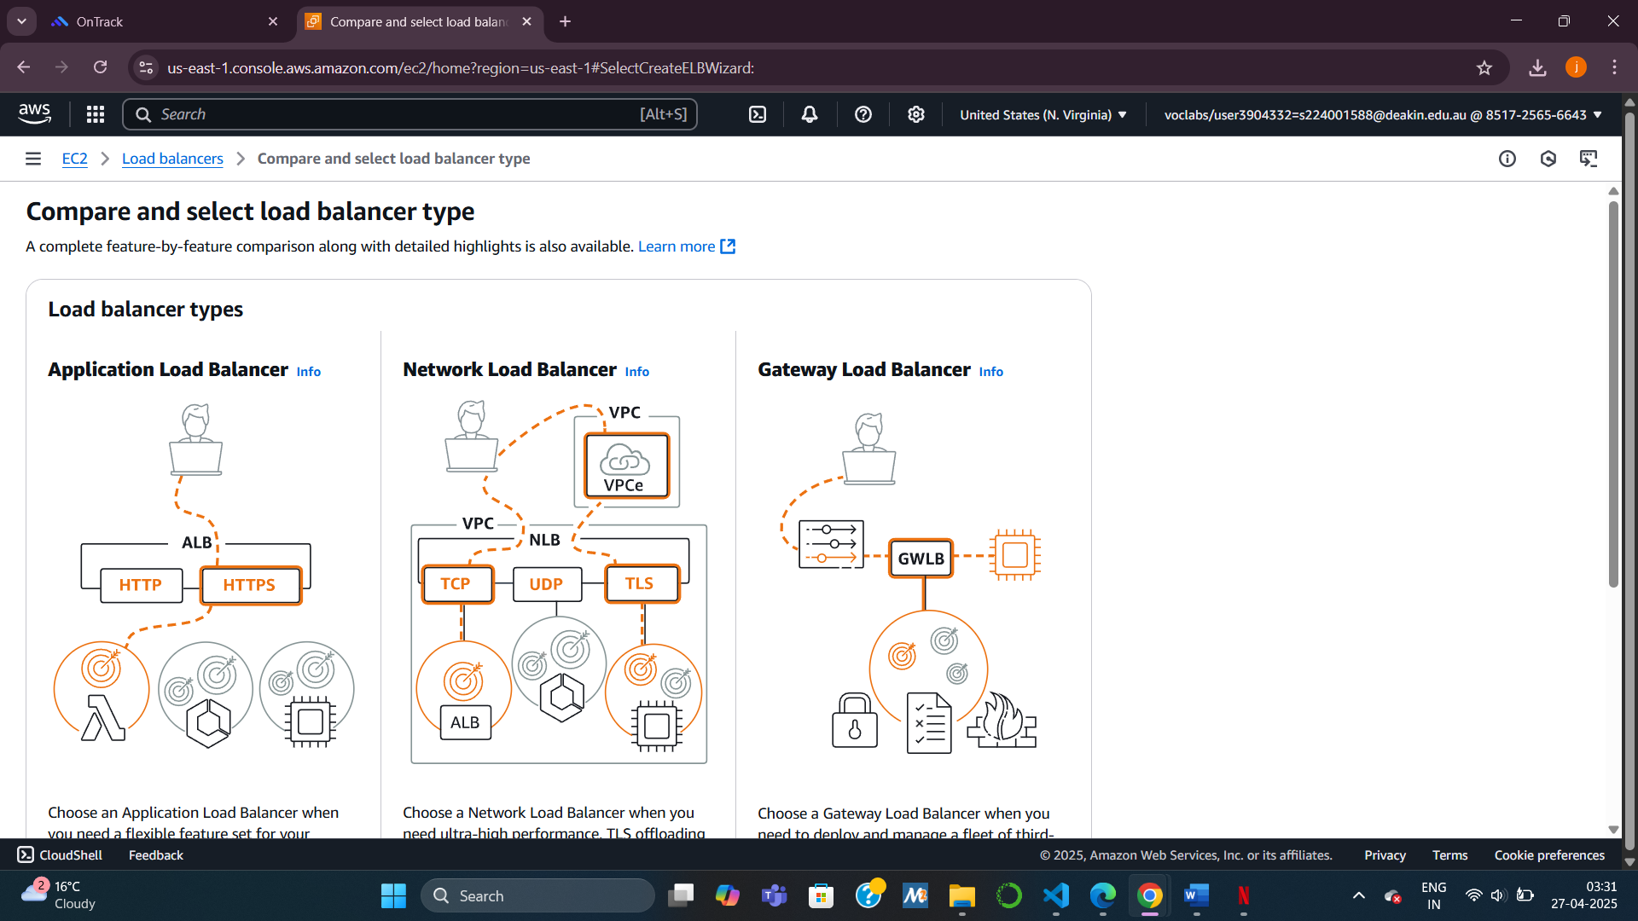

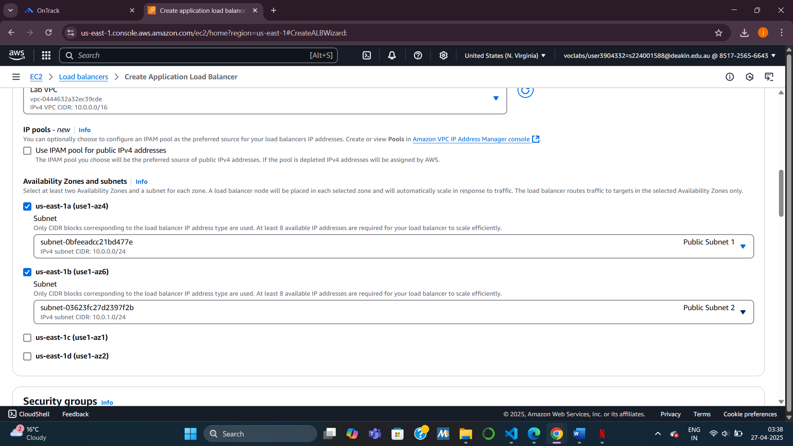

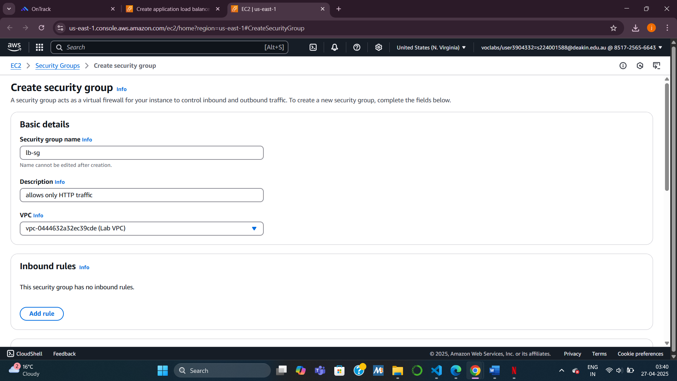

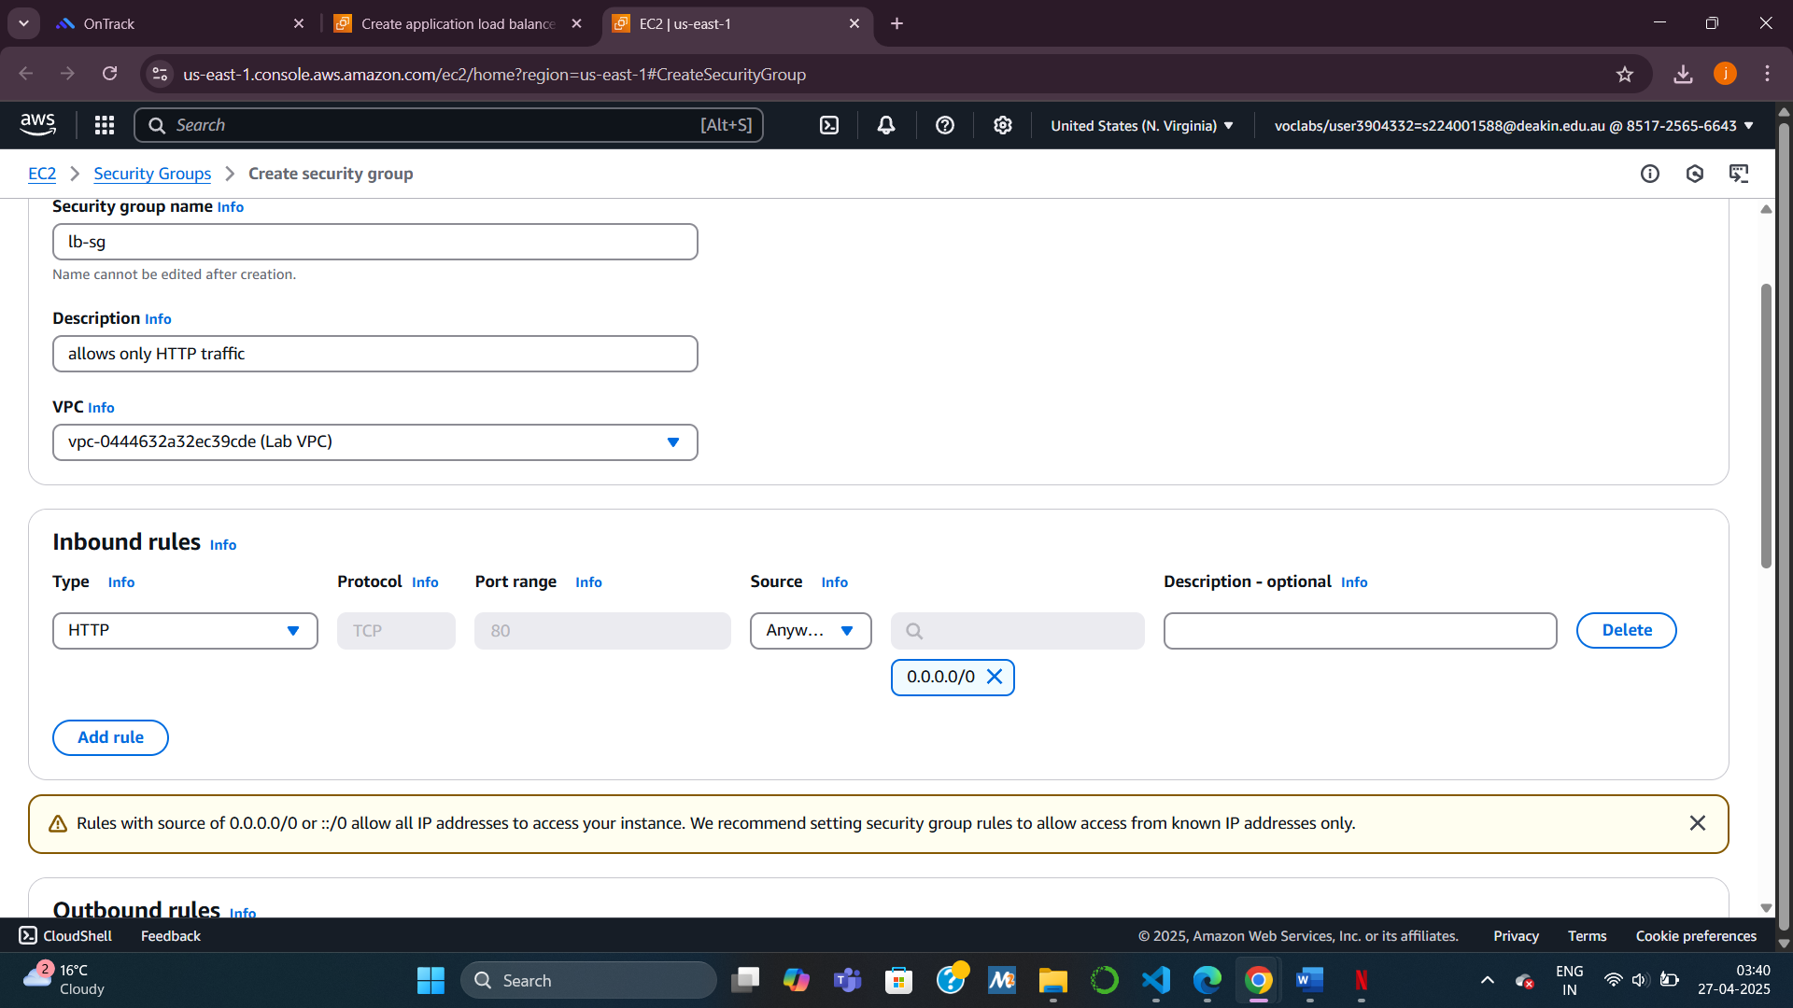

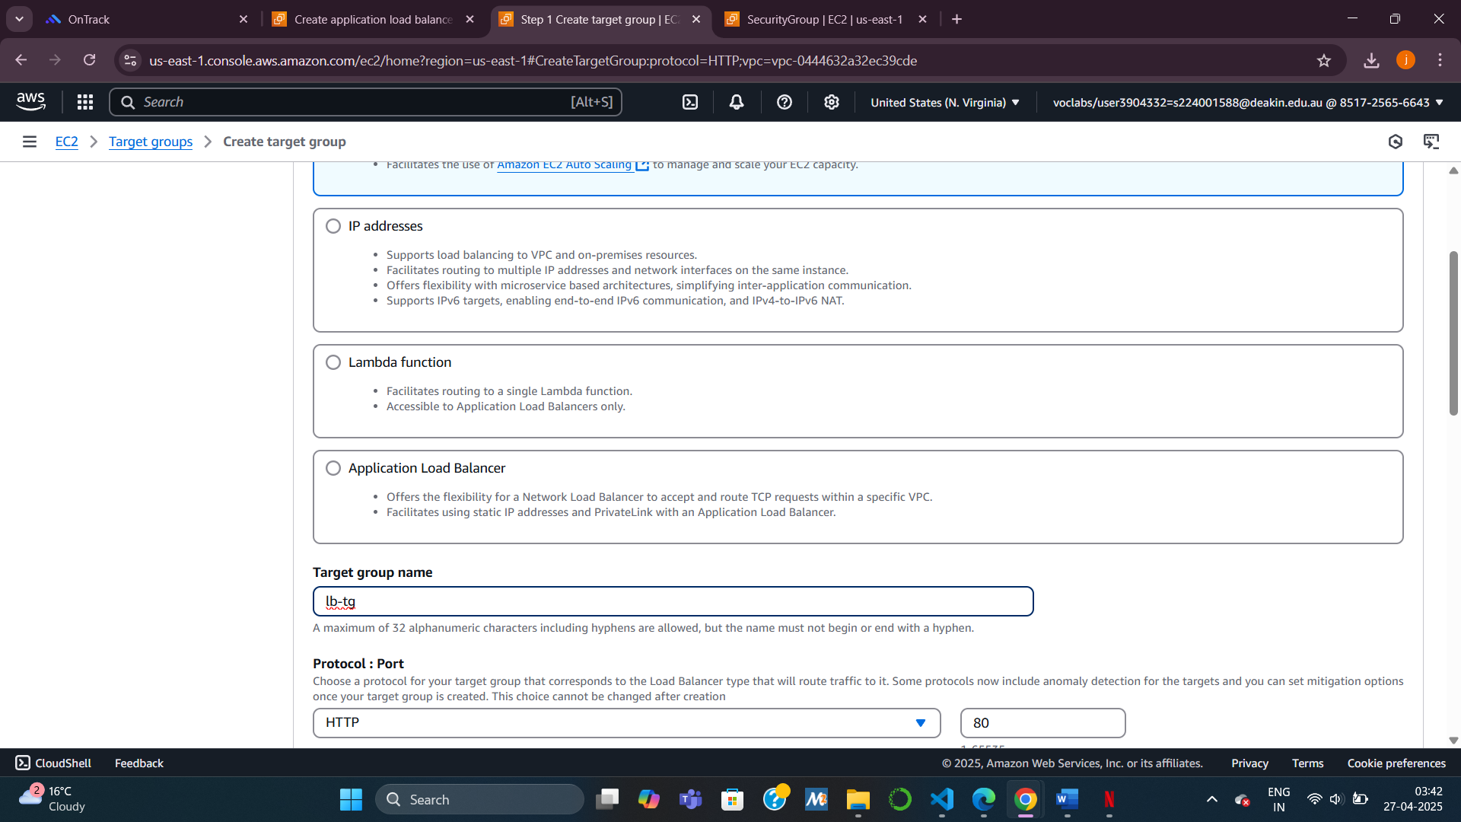

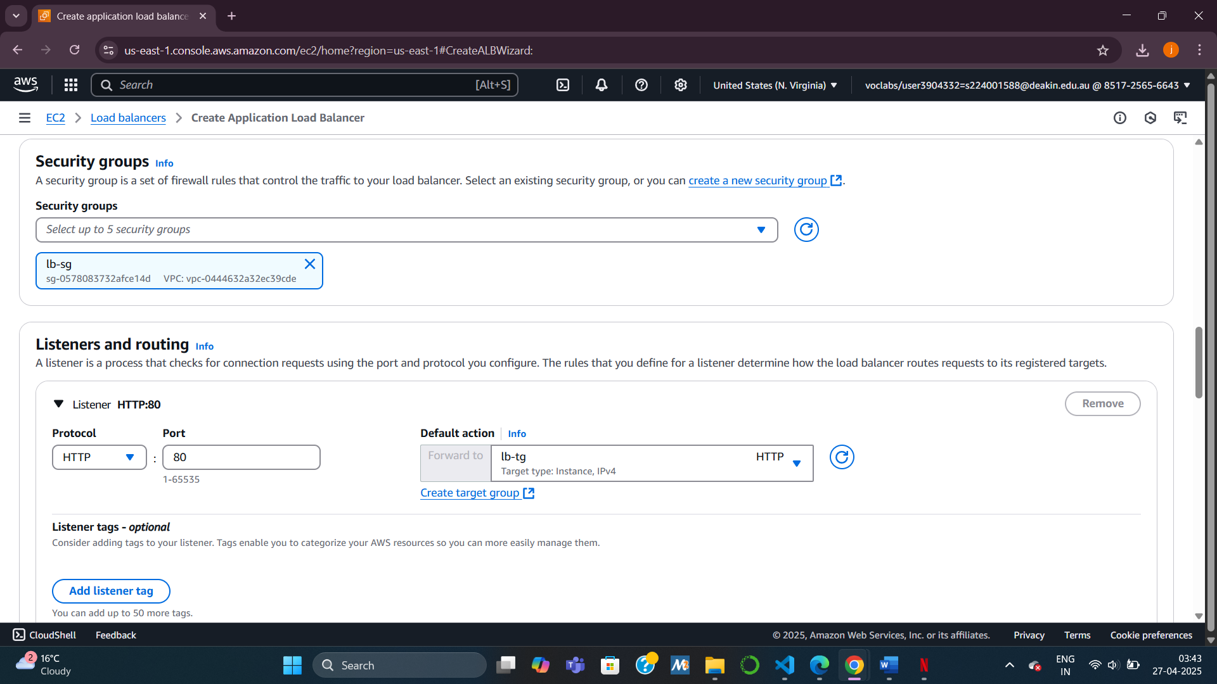

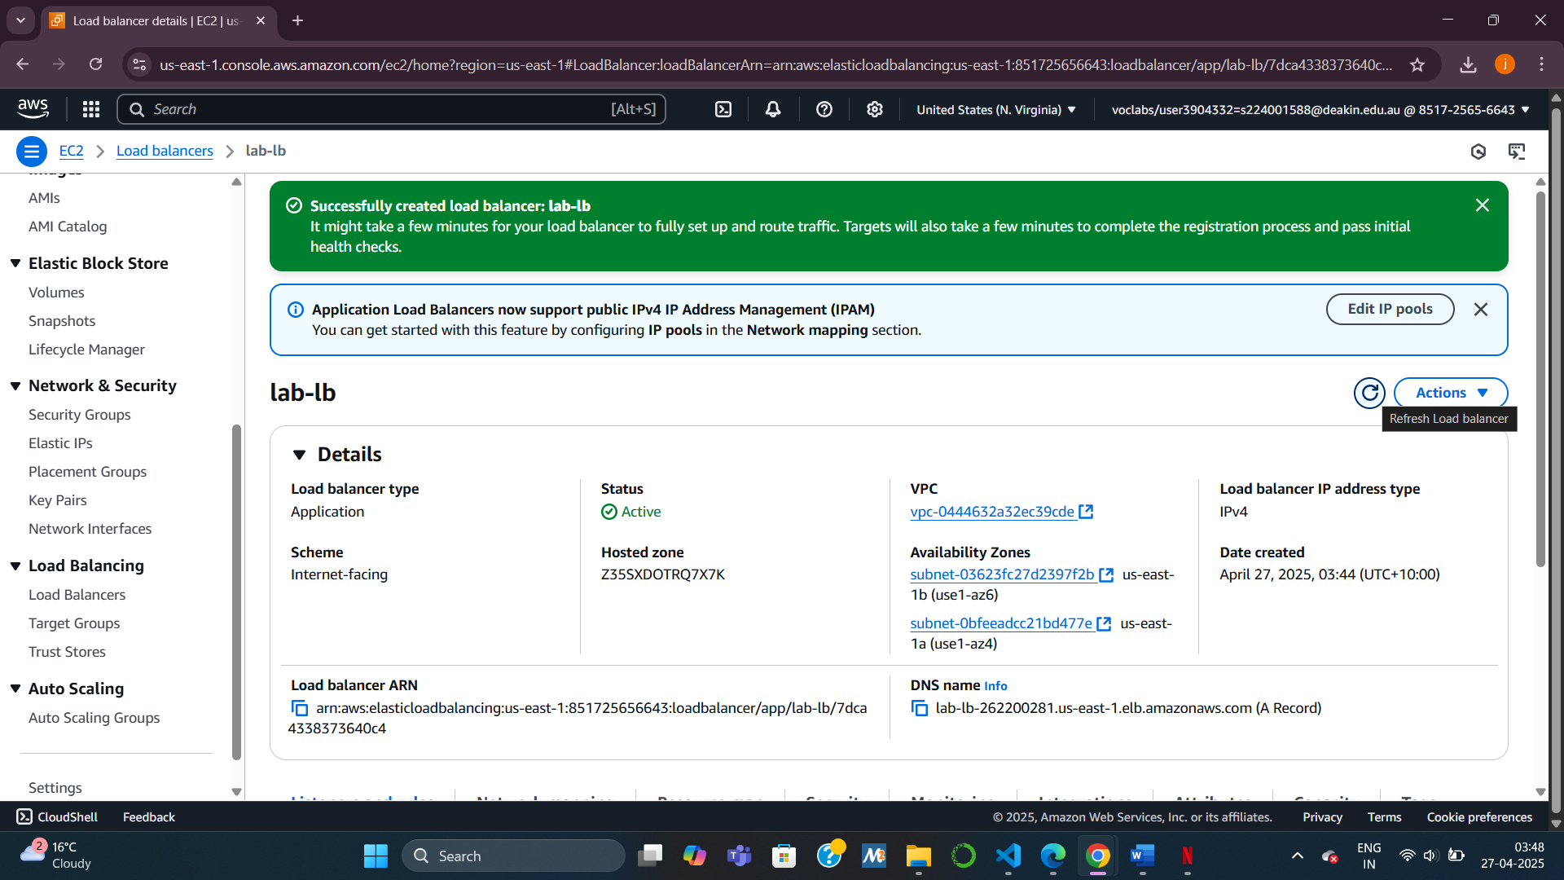

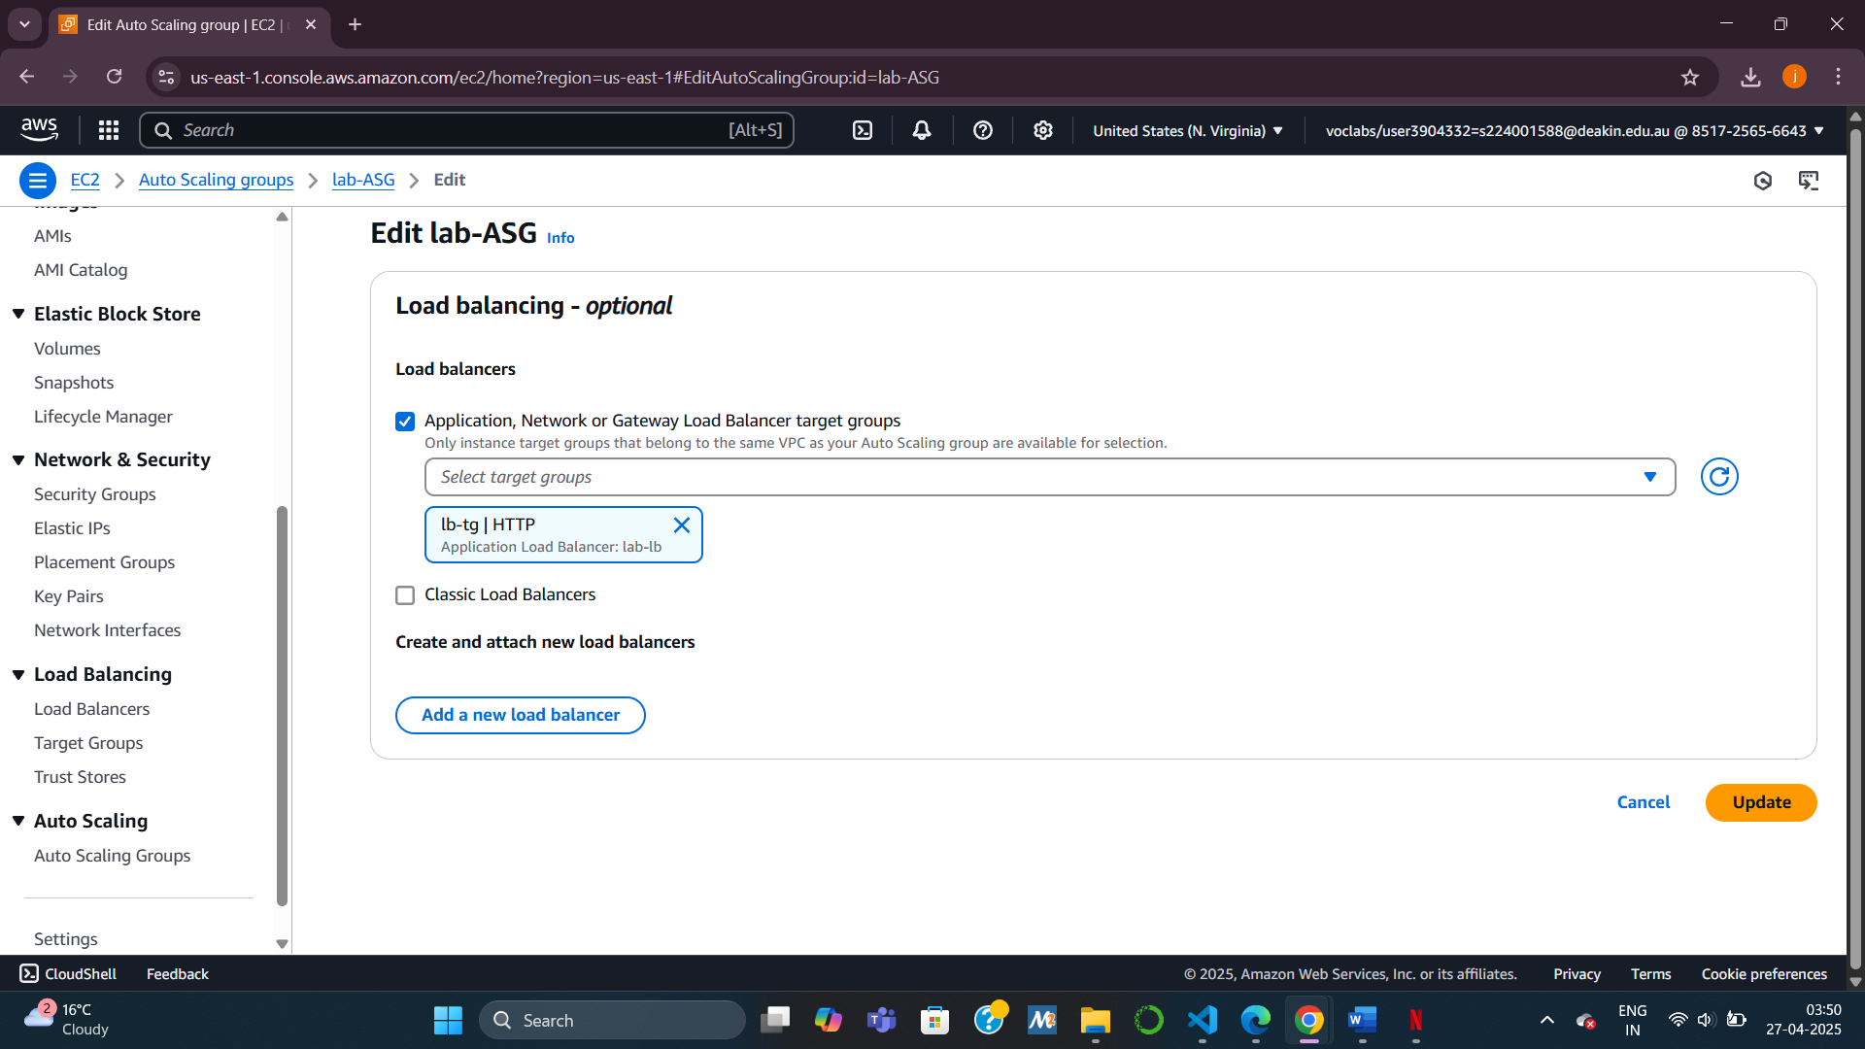

Task 6 : Testing the Web Application Without Load

What I did:  
I verified whether the web application was properly deployed and accessible through the load balancer.

How I did it:  
I visited the DNS URL of the ALB, appending /cafe at the end. The café application loaded successfully, confirming that the infrastructure was correctly set up and instances were receiving traffic via the load balancer.

If the page didn’t load, I knew to troubleshoot:

* NAT gateway routes
* Security group rules
* Launch template settings
* IAM role
* Subnet selection for Auto Scaling
* Load balancer target group mapping

